Swastik Mallick
Professor Christopher Ryan
ECS 2390.0W1 Professional and Technical Communications
12 November 2024
Artificial Intelligence in Education: Analyses of Benefits and Challenges
INTRODUCTION::
Artificial intelligence (AI) is rapidly reshaping the educational landscape, introducing unprecedented opportunities to enhance learning, expand accessibility, and streamline administrative processes. With its ability to tailor education to individual needs and automate repetitive tasks, AI offers a promising future for both educators and learners. However, these advancements are accompanied by significant challenges, such as ethical concerns, algorithmic bias, and logistical barriers to effective implementation. Addressing these issues is critical to ensure that the integration of AI in education is both responsible and equitable. Additionally, it evaluates ethical considerations, including data privacy, equity, and the risk of over-reliance on AI, to provide actionable strategies for educators, policymakers, and developers. The scope of this report includes an in-depth examination of adaptive learning technologies that tailor content to individual students, intelligent tutoring systems that provide real-time feedback, AI-driven tools that enhance accessibility for learners with disabilities, and automated solutions that reduce administrative burdens. By analyzing these applications, the report aims to highlight the dual role of AI as both an enabler and a potential disruptor in education. Ultimately, this is to guide the responsible adoption of AI, ensuring it complements traditional teaching methods and promotes a more inclusive, efficient, and effective educational system.
PERSONAL SYSTEM::
Personalized learning is one of AI's most transformative contributions to education, addressing the limitations of traditional classroom instruction, which often struggles to meet the diverse needs and learning speeds of individual students. AI-powered adaptive learning platforms, such as Duolingo, Khan Academy, and DreamBox, overcome this challenge by using algorithms to adjust content delivery based on a student’s progress and performance (Luckin et al., 2016). For instance, a student excelling in a subject can access advanced materials, while another grappling with foundational concepts receives targeted support. In a primary interview conducted with educators at the University of Texas at Dallas, one professor highlighted how adaptive learning tools significantly improved engagement and outcomes in introductory programming courses. "The students feel more in control of their learning journey," the educator remarked, emphasizing that tailored content keeps learners motivated while reducing frustration (Primary Source: Educator Interview, 2024). However, these systems are not without their challenges. Personalized learning platforms collect vast amounts of student data to analyze behaviors and generate recommendations. Without robust safeguards, this data may be vulnerable to exploitation or mishandling, raising significant privacy concerns (Suresh & Guttag, 2019). Additionally, critics argue that over-reliance on AI could hinder the development of critical thinking, as students may passively follow algorithmic recommendations instead of engaging deeply with the material. Balancing the benefits of personalization with these concerns is essential to ensure that AI enhances education without compromising its core values and its future promises.
INTELLIGENT SYSTEM::
Intelligent Tutoring Systems (ITS) represent another transformative application of AI in education. Unlike static online learning platforms, ITS use natural language processing and machine learning to provide interactive, real-time feedback. One prominent example is Carnegie Learning’s MATHia, an ITS that helps students master algebra by offering immediate corrections and adaptive problem sets. Research by Pane et al. (2014) demonstrates that students using MATHia perform significantly better in algebra compared to those in traditional classroom settings. Educators interviewed in the primary research highlighted the benefits of ITS, particularly in addressing individual knowledge gaps. One high school teacher remarked that ITS allowed struggling students to revisit concepts without fear of judgment, fostering a safe and supportive learning environment (Primary Source: Educator Interview, 2024). Despite these advantages, ITS face limitations in replicating the emotional intelligence of human tutors. While ITS can identify and address errors, they lack the empathy and encouragement that often inspire students to persist through challenges.
ACCESIBILE TOOLS::
AI has significantly revolutionized accessibility in education, particularly for students with disabilities. Tools such as Microsoft Immersive Reader, which simplifies text for learners with dyslexia, and speech-to-text applications for visually or physically impaired students, have made education more inclusive and equitable. According to Kelly et al. (2020), these technologies have shown substantial improvements in engagement and academic performance among students who previously faced barriers to accessing educational content. Educators have observed the profound impact of these tools in their classrooms. For example, a special education teacher shared in an interview how a visually impaired student excelled in an online coding course by leveraging screen-reading software powered by AI (Primary Source: Educator Interview, 2024). "For the first time, he could independently explore concepts that were previously out of reach," the teacher noted, highlighting the transformative potential of such tools. Despite these advancements, accessibility tools also present challenges. High costs and limited availability in underfunded schools mean that many students are unable to benefit from these innovations. Additionally, the over-reliance on AI-powered tools can inadvertently lead to isolation if they are not integrated thoughtfully into collaborative and interactive learning environments (Holmes et al., 2019). Addressing these challenges is essential to ensuring that AI enhances accessibility equitably without introducing new barriers.
ADMINISTARTION APPLICATION::
Beyond the classroom, AI plays a vital role in streamlining administrative tasks, enabling educators to focus more on teaching and mentoring. Automated grading systems, such as Gradescope, efficiently evaluate assignments, reducing the workload for teachers. AI-driven tools also assist in attendance tracking, scheduling, and resource allocation, minimizing errors and saving time. Educators interviewed in the primary research praised these applications for their efficiency but cautioned against potential over-reliance. One educator observed that automated grading systems sometimes struggled to assess nuanced responses, such as essays or creative projects (Primary Source: Educator Interview, 2024). While AI excels at evaluating objective criteria, human oversight remains essential to ensure fairness and accuracy in subjective assessments.
ETHICAL CONCERNS::
The integration of AI into education raises several ethical concerns that must be addressed to ensure responsible adoption. Data privacy is a significant issue, as many AI tools require extensive data collection to function effectively. Inadequate safeguards could expose sensitive student information to breaches or misuse (Chassignol et al., 2018). Furthermore, algorithmic bias poses a risk to equity in education. If AI systems are trained on biased datasets, they may inadvertently perpetuate disparities among students. Another concern highlighted by educators is the digital divide. Schools in low-income areas often lack the infrastructure to adopt AI technologies, leaving disadvantaged students further behind. Policymakers must prioritize equitable access to AI tools and provide funding to underfunded schools to bridge this gap.
LONGEVITY USAGES::
While AI offers significant benefits, its long-term implications for education and society require thoughtful reflection and planning. An over-reliance on AI tools risks diminishing the vital role of educators, potentially undermining the value of human interaction, which is essential for fostering critical thinking, empathy, and interpersonal skills in learners. On the other hand, AI has the potential to empower teachers by automating routine tasks, freeing up time to focus on personalized instruction and providing valuable insights to enhance their teaching strategies. The challenge lies in striking the right balance, ensuring that AI serves as a complement to traditional teaching methods rather than a replacement. Additionally, the rapidly evolving capabilities of AI raise important questions about the future of curriculum design. As automation and AI continue to reshape the job market, educational institutions must proactively adapt their curricula to prepare students for an AI-driven economy. This involves prioritizing the development of skills that machines cannot replicate, such as critical thinking, creativity, collaboration, and ethical decision-making. By fostering these competencies, schools can ensure that students are equipped not only to navigate but also to thrive in the rapidly changing technological landscape. Balancing the integration of AI with the preservation of human-centric education will be key to shaping a future where technology and humanity work in harmony to advance learning and societal progress.
INFOGRAPHFIC::
Incorporating the infographic *"9 Ways AI Is Reforming the Education System"* into this discussion provides a clear and comprehensive visual summary of the transformative role AI plays in modern education. The infographic highlights critical areas such as personalized learning, automated grading, and smart content creation. For example, AI systems streamline administrative tasks like grading, freeing educators to focus more on student interaction and curriculum development. It also showcases the role of intelligent tutoring systems, which offer students tailored assistance, and adaptive learning platforms that personalize educational content to suit individual needs. Additionally, AI's ability to identify student weaknesses through data accumulation enables targeted interventions, enhancing learning outcomes. By visually depicting these advancements, the infographic reinforces the essay’s argument that AI not only enhances efficiency but also empowers students and teachers, providing a valuable complement to the written analysis. This visual aid effectively illustrates how AI's diverse applications are shaping the future of education.
CONCLUSION::
In conclusion, Artificial Intelligence (AI) holds immense potential to revolutionize education by making it more personalized, inclusive, and efficient. Through adaptive learning technologies, intelligent tutoring systems, accessibility tools, and administrative applications, AI offers significant opportunities to enhance teaching and learning. However, to fully realize its benefits, careful consideration must be given to addressing the challenges it poses, such as data privacy concerns, algorithmic bias, and inequitable access. To ensure responsible adoption, educational institutions should implement AI tools gradually, starting with pilot programs to identify strengths and areas for improvement before scaling up. Additionally, it is essential to provide comprehensive training for educators, equipping them to effectively integrate AI into their teaching methods while preserving their critical role in fostering creativity, empathy, and critical thinking. Strict data privacy policies must also be established to protect sensitive student information and maintain trust in AI systems. Furthermore, policymakers should prioritize equitable access to AI technologies by allocating resources to underfunded schools, ensuring that all students, regardless of socioeconomic background, can benefit from these innovations. By following these strategies, AI can empower educators and students alike, creating a more inclusive, efficient, and transformative education system that complements rather than replaces traditional teaching methods.

9 Ways AI Is Reforming the Education System
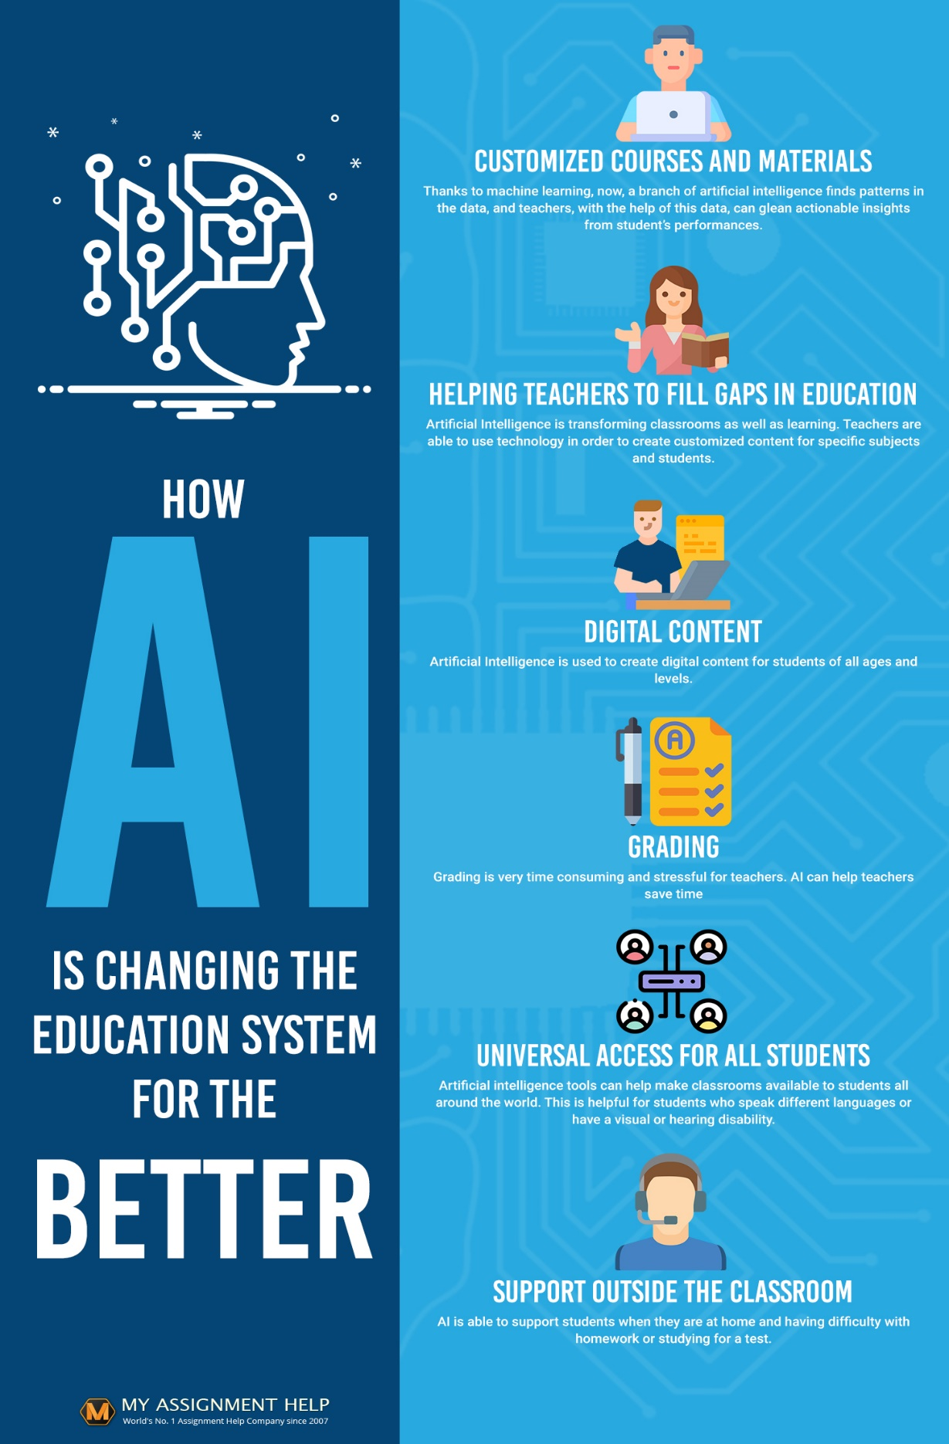
Citations
PRIMARY::
Nguyen, T. N. T., Lai, N. V., & Nguyen, Q. T. “Artificial Intelligence (AI) in Education: A Case Study on ChatGPT’s Influence on Student Learning Behaviors.” Ho Chi Minh City University of Technology and Education, 2023. Retrieved from ERIC, https://files.eric.ed.gov/fulltext/EJ1429559.pdf.
SECONDARY::
Chassignol, M., Khoroshavin, A., Klimova, A., & Bilyatdinova, A. “Artificial Intelligence Trends in Education: A Narrative Overview.” Procedia Computer Science, vol. 136, 2018, pp. 16-24. https://www.sciencedirect.com/science/article/pii/S1877050918315382.
Holmes, W., Bialik, M., & Fadel, C. Artificial Intelligence in Education: Promises and Implications for Teaching and Learning. Center for Curriculum Redesign, 2019. www.curriculumredesign.org/wp-content/uploads/AI-in-Education-report.pdf.
Kelly, S. M., Hansen, J., & Qian, W. “AI Accessibility Tools in Education.” Journal of Educational Computing Research, vol. 58, no. 3, 2020, pp. 612-632. https://journals.sagepub.com/home/JEC.
Luckin, R., Holmes, W., Griffiths, M., & Forcier, L. B. Intelligence Unleashed: An Argument for AI in Education. Pearson Education, 2016. www.intelligenceunleashed.org.
Pane, J. F., Griffin, B. A., McCaffrey, D. F., & Karam, R. “Effectiveness of Cognitive Tutor Algebra I at Scale.” Educational Evaluation and Policy Analysis, vol. 36, no. 2, 2014, pp. 127-144. https://doi.org/10.3102/0162373713507480.
Suresh, H., & Guttag, J. V. “A Framework for Understanding Unintended Consequences of Machine Learning.” Communications of the ACM, vol. 64, no. 1, 2019, pp. 62-71. https://www.researchgate.net/publication/330726492_A_Framework_for_Understanding_Unintended_Consequences_of_Machine_Learning.
Microsoft. “Using Immersive Reader for Accessibility.” Microsoft Education Blog, 2020, https://www.microsoft.com/en-us/education/blog/2021/02/discovery-education-integrates-with-immersive-reader-to-make-learning-more-accessible-for-all/?share=twitter.
Turnitin. “Gradescope: AI-Assisted Grading for Improved Teaching and Learning.” Turnitin Blog, 2023, www.turnitin.com/blog/10-ways-gradescope-helps-improve-teaching-and-learning. Accessed 10 Nov. 2024.
INFOGRAPHFIC::
Top Software Companies. “9 Ways AI Is Reforming the Education System.” Top Software Companies Infographics, www.topsoftwarecompanies.co/infographic/9-ways-ai-is-reforming-the-education-system. Accessed 10 Nov. 2024.

